Postdoctoral Position in Electrochemistry
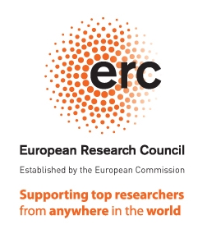
Nanoparticles in Carbon Nanotubes (ERC-StG project)
FunNanoMatLab group led by Dr. Maria Gimenez is seeking for 1 Postdoctoral Research Fellow with a strong background in Electrochemistry to join the team @CiQUS

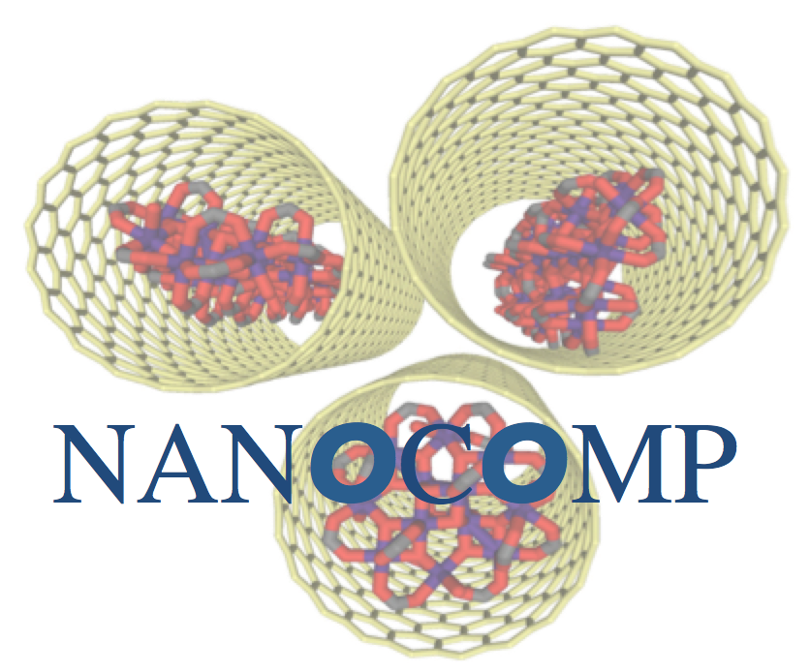
The selected candidate will take part to the cutting-edge research project (NANOCOMP) funded by the European Commission (ERC-Starting Grant), having as a primary goal the development of a new model systems hybrid metal-carbon nanomaterials to study frontier concepts in energy-related applications. Understanding and controlling electrochemical responses of confined nanoscale species on carbon nanocontainers in conversion and energy-storage is the main vector of this project.

DESCRIPTION
The selected candidate will work on the preparation of energy-storage components (e.g. batteries) incorporating, exploring and optimizing novel hybrid carbon nanostructures functionalized with tailored-made redox active components.

REQUIREMENTS
We are seeking for an outstanding individual holding a PhD in Chemistry/Materials Science or a relevant subject area, capable to keep her/his own timely progress while supervising fellow PhDs and MSc students as a senior team member. The selected candidate will be a self-starter, creative and team-player, willing to work in a dynamic environment. Good knowledge of electrochemistry theory and characterization methods is required in the field of energy storage. Excellent communication skills and proficiency in written and spoken English are essential.

REFERENCES
“Extremely Stable Platinum-Amorphous Carbon Electrocatalyst within Hollow Graphitized Carbon Nanofibers for the Oxygen Reduction Reaction”, M.C. Gimenez-Lopez et al. Adv. Mater., 2016, 28, 41, 9103 – 9108.
“Assembly and Magnetic Bistability of Mn₃O₄ Nanoparticles Encapsulated in Hollow Carbon Nanofibers”, M.C. Gimenez-Lopez et al. Angew. Chem. Int. Ed., 2013, 52, 2051 –2054.
“Encapsulation of Single-molecule Magnets in Carbon Nanotubes“, M.C. Gimenez-Lopez et al. Nature Communications, 2011, 2:47

STARTING DATE AND TERM
ASAP. Applications will be considered as received, >1 year contract with salary commensurate with experience and demonstrated skills.
APPLICATIONS AND DEADLINE
Applications should be addressed to Dr. Maria Gimenez-Lopez and sent via email in a single PDF file to maria.gimenez.lopez@usc.es including a motivation letter, CV with publications, a short description of previous research and the names and e-mail addresses of two academic references, indicating in the subject NANOCOMP-CiQUS-POSTDOC-ENERGY-ELECTROCHEMISTRY/BATTERIES.
Postdoctoral Position in Electrocatalysis
Nanoparticles in Carbon Nanotubes (ERC-StG project)
FunNanoMatLab group led by Dr. Maria Gimenez is seeking for 1 Postdoctoral Research Fellow with a strong background in Electrocatalysis to join the team @CiQUS

The selected candidate will take part to the cutting-edge research project (NANOCOMP) funded by the European Commission (ERC-Starting Grant), having as a primary goal the development of new model systems hybrid metal-carbon nanomaterials to study frontier concepts in energy-related applications. Understanding and controlling electrochemical responses of confined nanoscale species on carbon nanocontainers in electrocatalysis and energy-storage is the main vector of this project.

DESCRIPTION
The selected candidate will work on the preparation, functionalization and characterization of electrocatalysts through the development of novel hybrid carbon nanostructures for energy-storage applications.

REQUIREMENTS
We are seeking for an outstanding individual holding a PhD in Chemistry/Materials Science or a relevant subject area, capable to keep her/his own timely progress while supervising fellow PhDs and MSc students as a senior team member. The selected candidate will be a self-starter and creative team-player willing to work in a dynamic environment. Good knowledge of catalysis and materials is required. Excellent communication skills and proficiency in written and spoken English are essential.

REFERENCES
“Extremely Stable Platinum-Amorphous Carbon Electrocatalyst within Hollow Graphitized Carbon Nanofibers for the Oxygen Reduction Reaction”, M.C. Gimenez-Lopez et al. Adv. Mater., 2016, 28, 41, 9103 – 9108.
“Assembly and Magnetic Bistability of Mn₃O₄ Nanoparticles Encapsulated in Hollow Carbon Nanofibers”, M.C. Gimenez-Lopez et al. Angew. Chem. Int. Ed., 2013, 52, 2051 –2054.
“Encapsulation of Single-molecule Magnets in Carbon Nanotubes“, M.C. Gimenez-Lopez et al. Nature Communications, 2011, 2:47

STARTING DATE AND TERM
ASAP. Applications will be considered as received, >1 year contract with salary commensurate with experience and demonstrated skills
APPLICATIONS AND DEADLINE
Applications should be addressed to Dr. Maria Gimenez-Lopez and sent via email in a single PDF file to maria.gimenez.lopez@usc.es including a motivation letter, CV with publications, a short description of previous research and the names and e-mail addresses of two academic references, indicating in the subject NANOCOMP-CiQUS-POSTDOC-ENERGY-ELECTROCATALYSIS.

